**DIGITAL MARKETING ASSIGNMENT**



BE – Computer Science and Engineering

Vivekananda College of Technology for Women

Namakkal - 637205

**NM id:** 06DCEB143219F53A26B4E9DEF0F8ED32

**Submitted By:**

KALPANA SHREE V

**Register Number:**

AU613020104032

* **BRAND NAME:**

Dikstra Academy

* **LOGO:**



* **CATEGORY:**

Learning Academy

1. **Create a blog or website using Blogspot and WordPress.**

Blogspot: <https://dikstraacademy.blogspot.com>

WordPress: <https://dikstraacademy.blogspot.com/2023/10/newsletter-october.html>

1. **Create a New Facebook Business Page and Post one social media poster**

Business Page link: <https://dikstraacademy.blogspot.com/2023/10/newsletter-october.html>



Social media Poster:

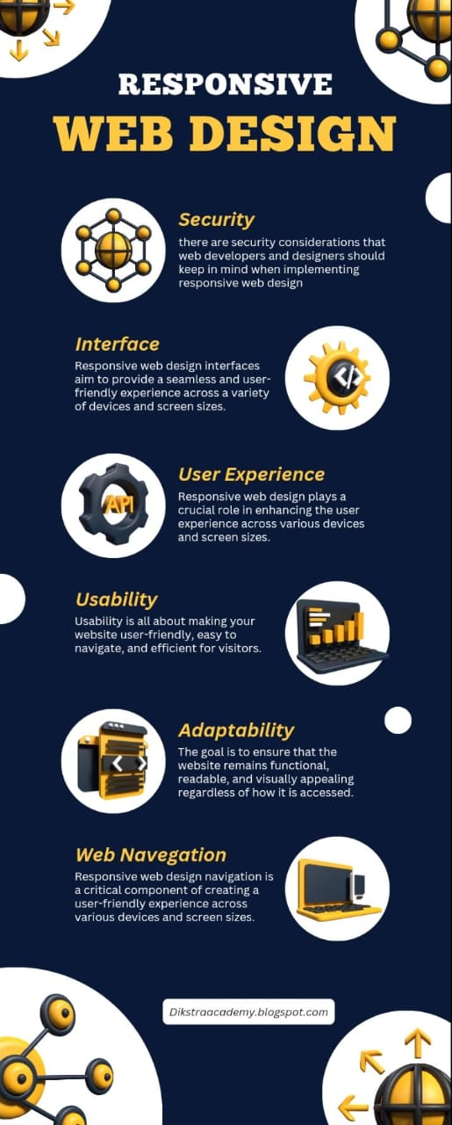

1. **Social media advertisement poster using Canva.**



1. **Email newsletter using MailChimp or Canva.**

